These answers may be fake news – pls help :)

Q1

A) Fixed-Income Securities Lecture Slides

B)

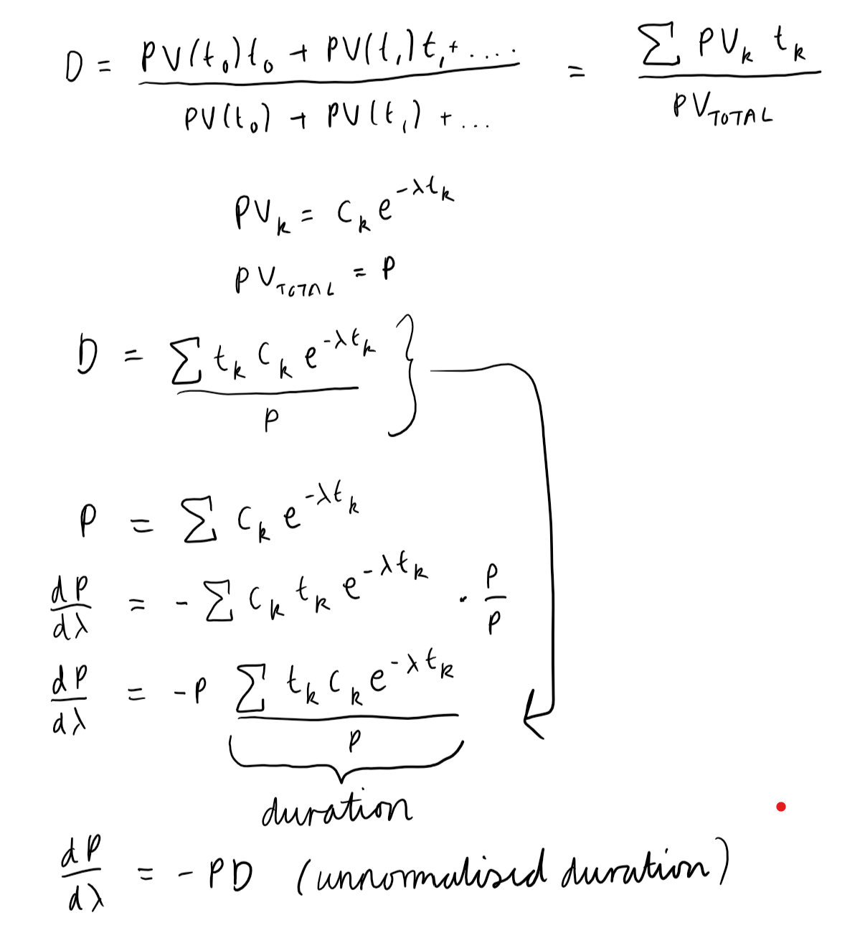

C)

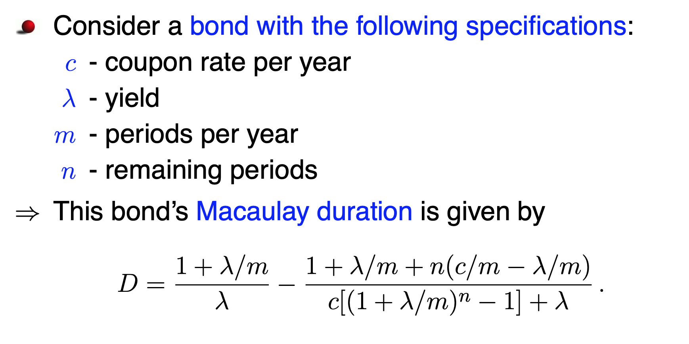

As n tends to infinity, the denominator of the second term increases exponentially, and the second term tends to 0. Hence, we are left with just the first term.

D) T^2

E)

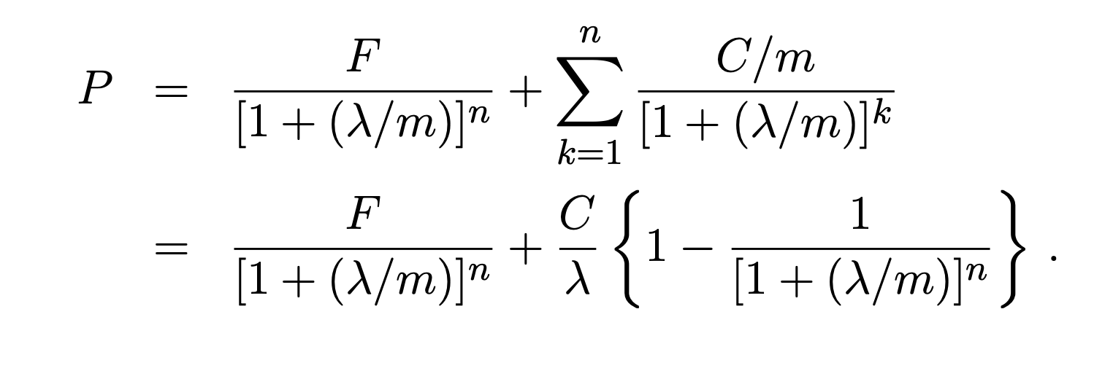

Into the last line, substitute in C = rF (coupon payment = coupon rate * Face value) and let r=lambda. Bish, bash, bosh, bob’s ur uncle - everything cancels out and we have P=F

Q2

A)

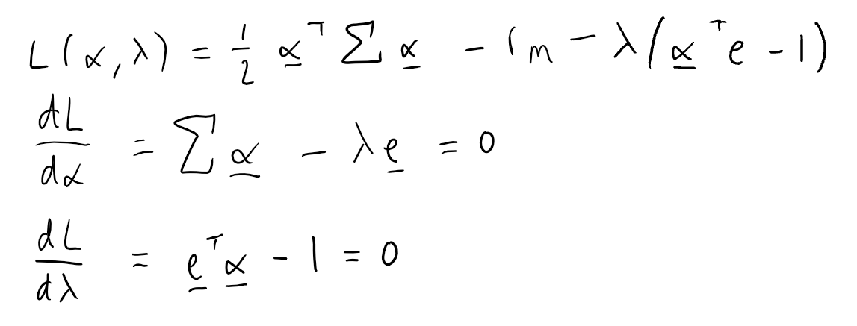

B)

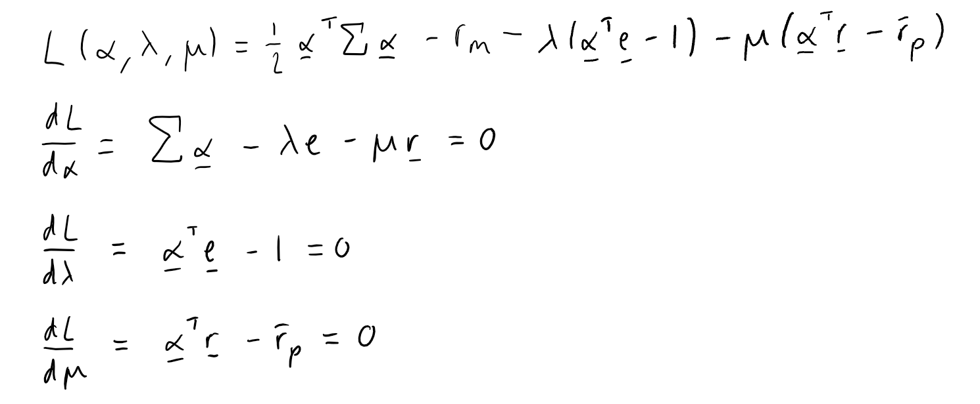

C)

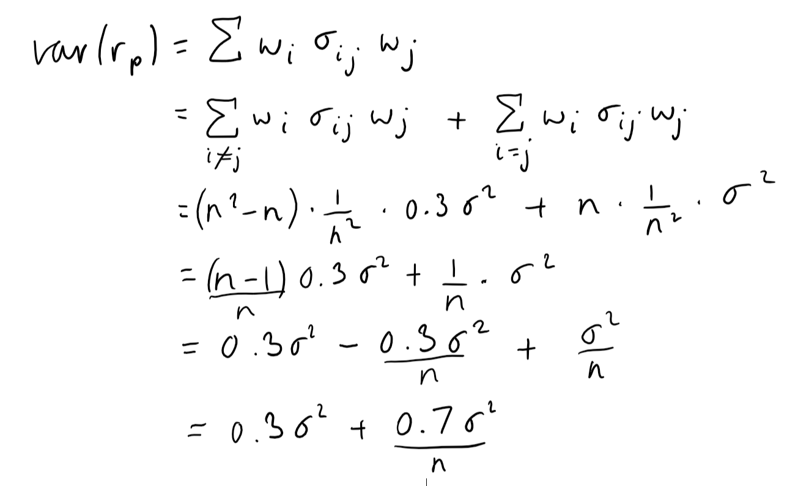

D) Assuming the face value of the bond is 1: If we consider the opposite of the inequality i.e. C(S,T) < max(0,S-KB(T)) then we can buy K bonds at B(T), buy 1 call and short sell a stock for an immediate reward of S-KB(T)-C (as 0 < S-KB(T)-C). At the expiry T, if S(T) > K, we get K from the bonds, S(T) - K for exercising the call and -S(T) from buying the stock back (Type A). On the other hand, if at expiry S(T) < K, we don't exercise the call but we still get K from the bonds and then -S(T) from buying back the stock which gives a profit of K-S(T) (Type B).

E) As time T -> Infinity, S_0 >= C_0 >= Max(0, S_0 / (1+r) ^ T) = Max(0, S_0)

Q3

A) doesn’t change

B) 616on

7,63.

Q4

Ai)

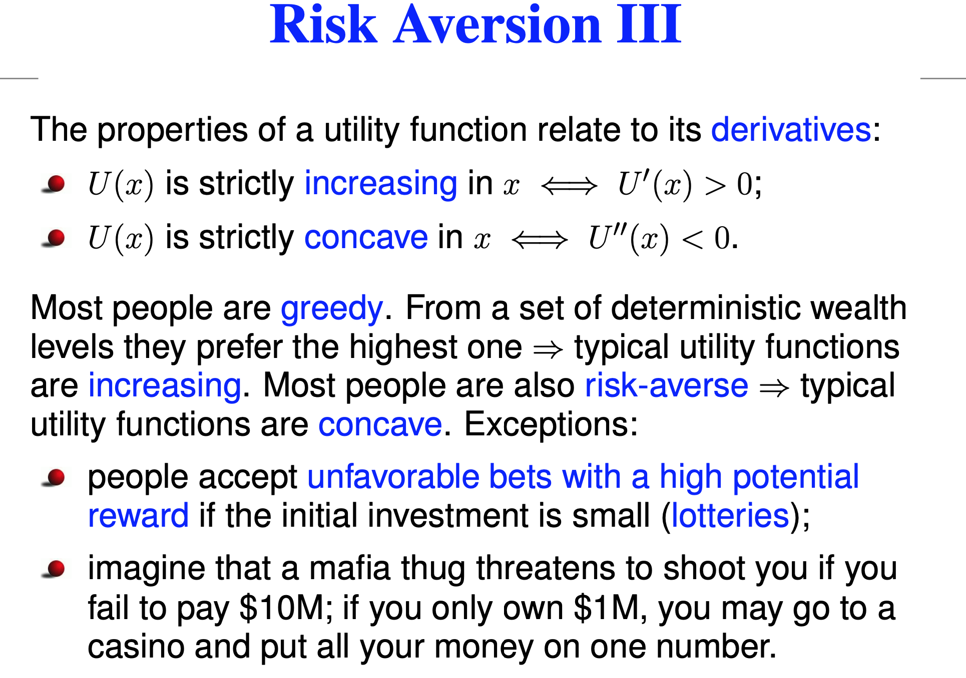

Aii) 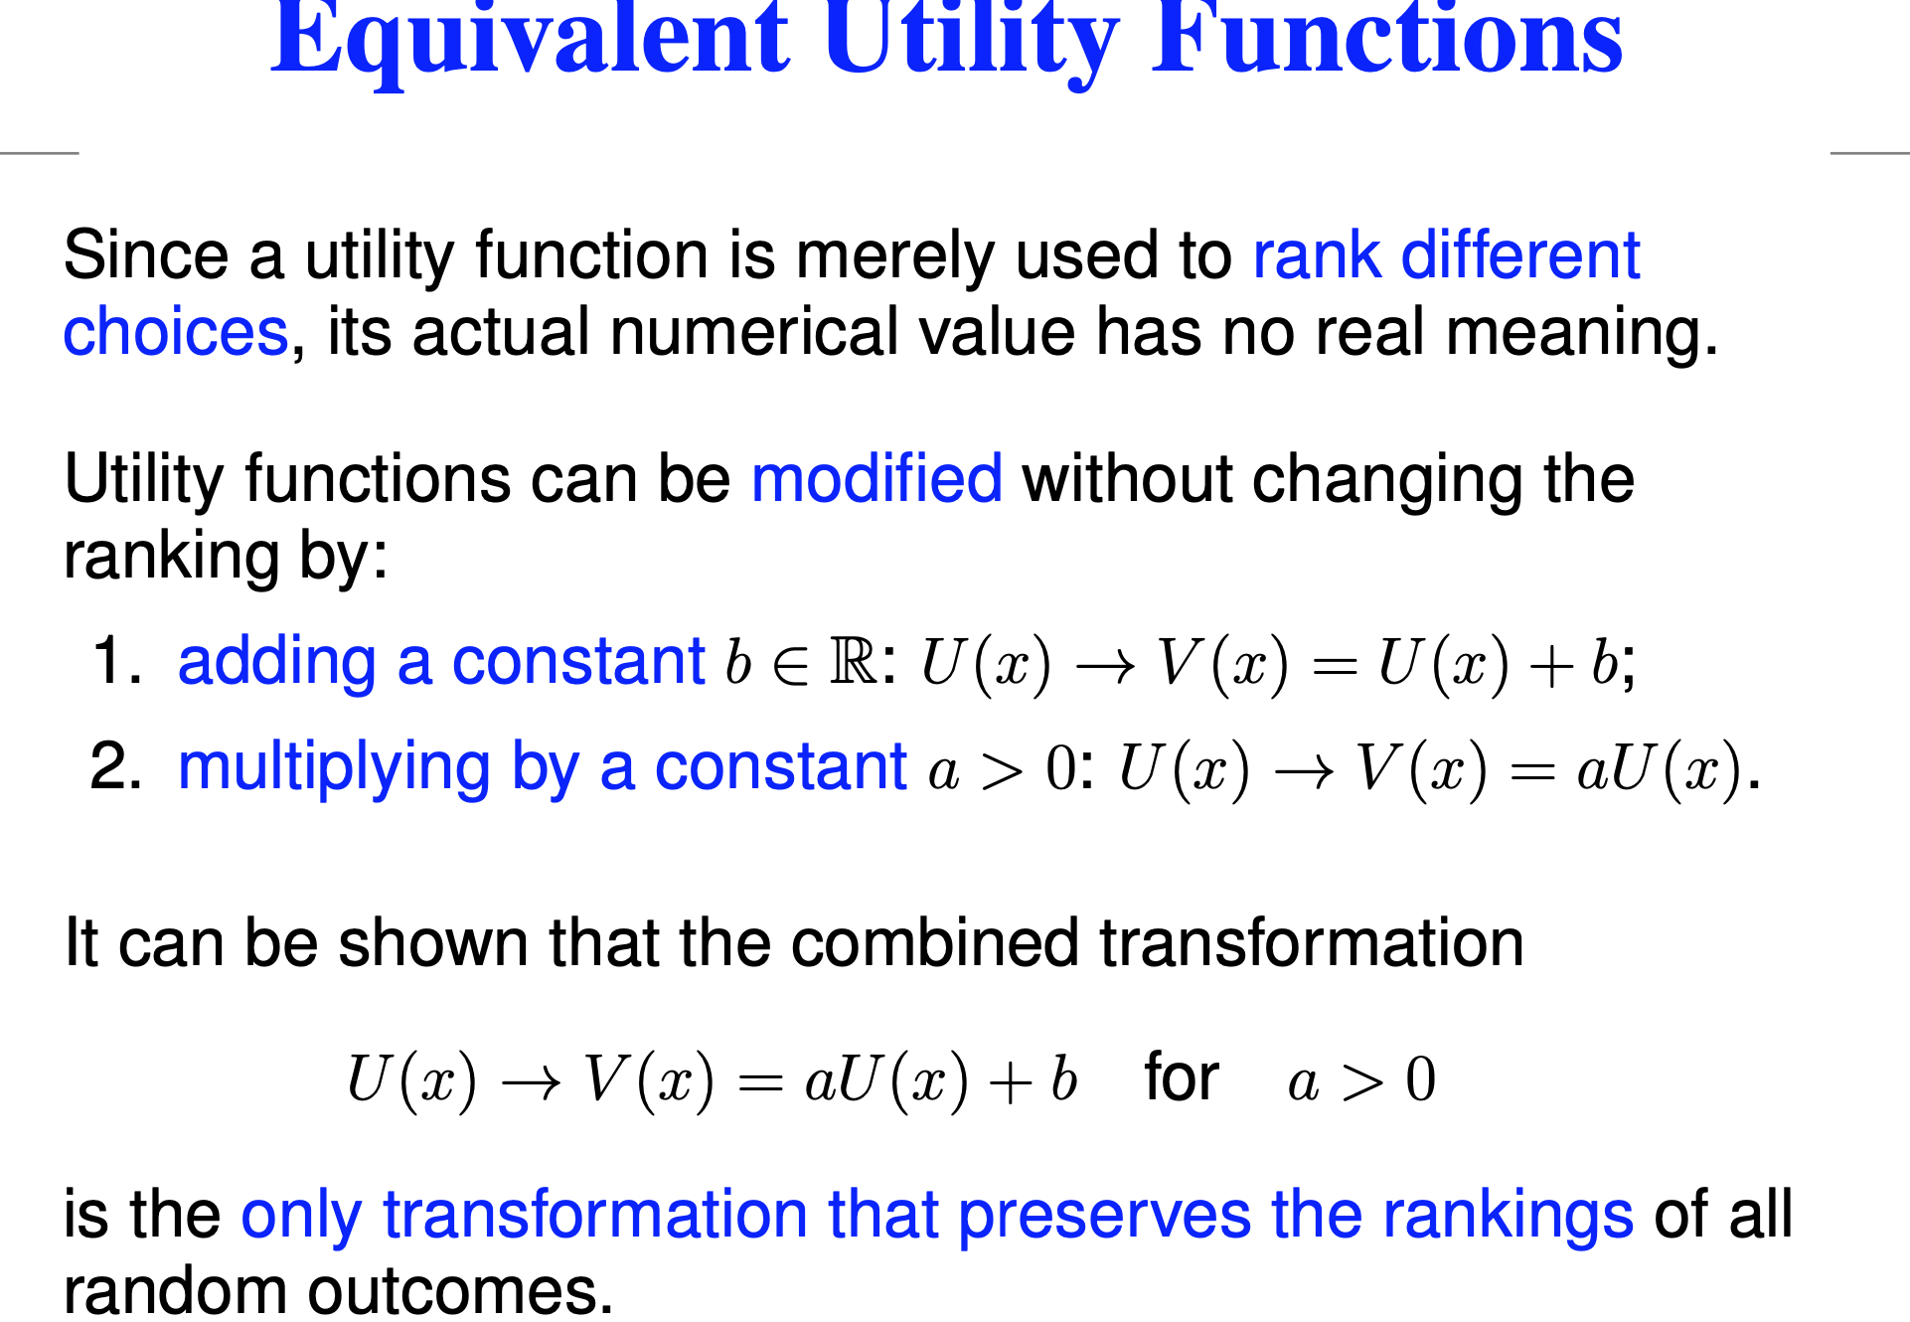

Aiii)

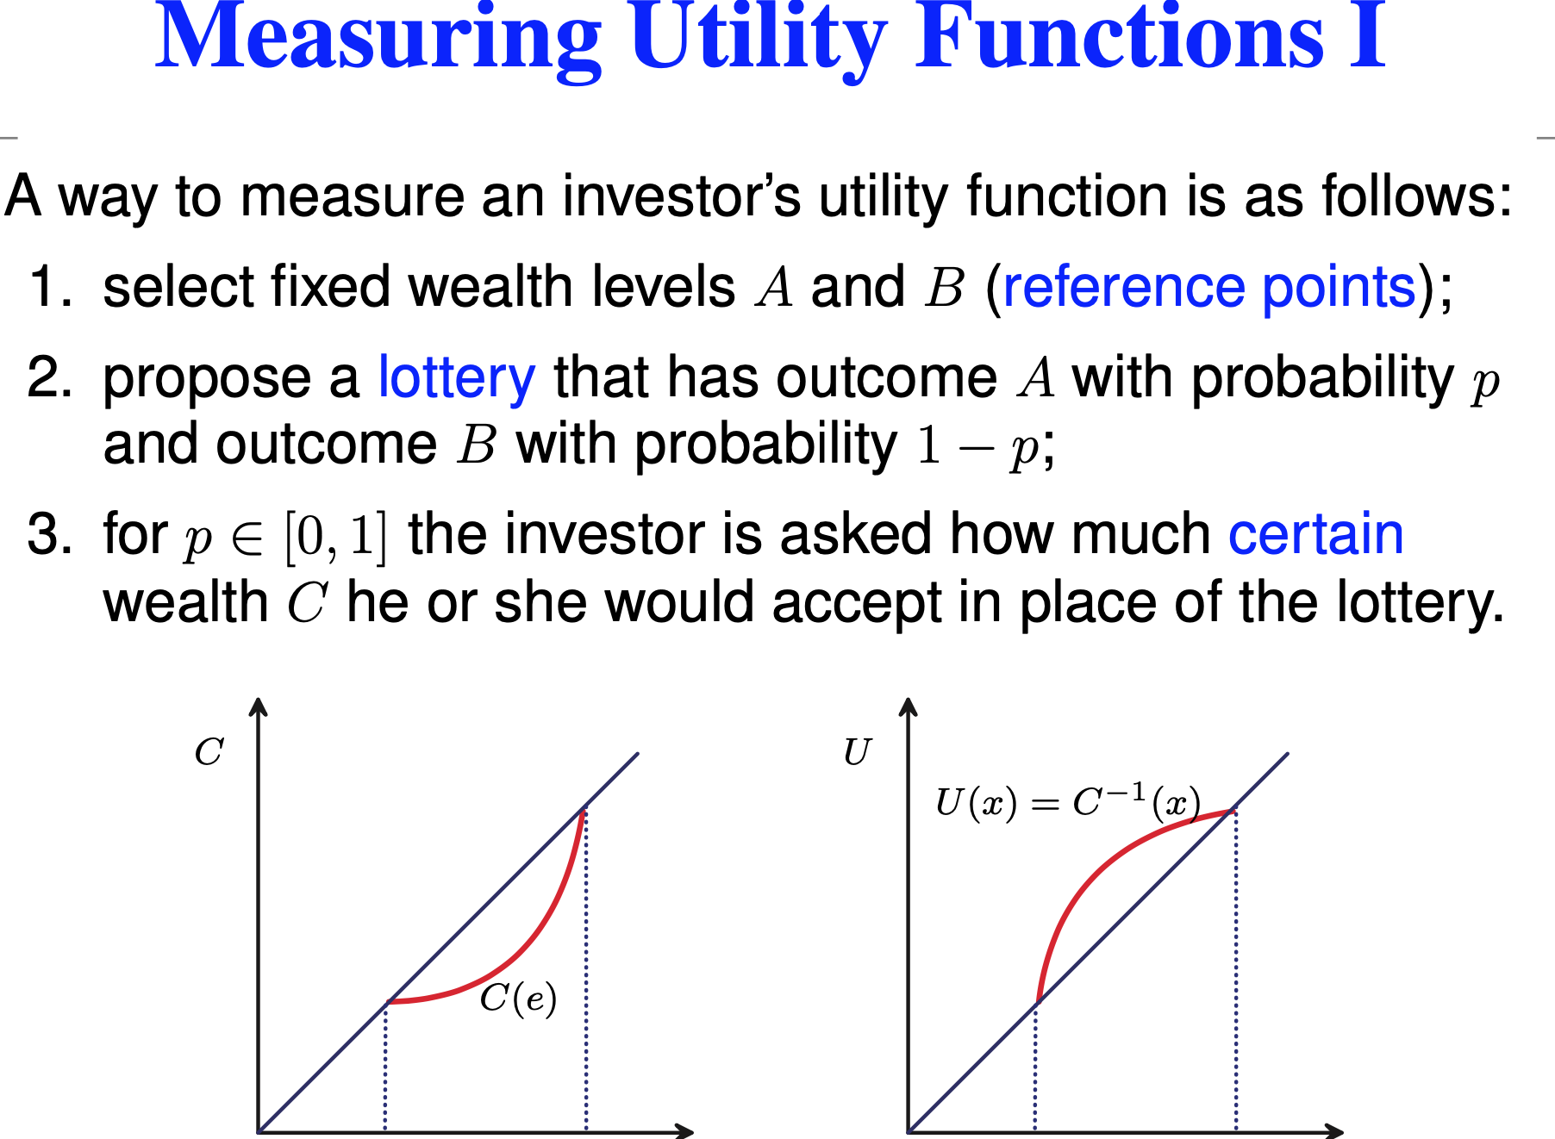 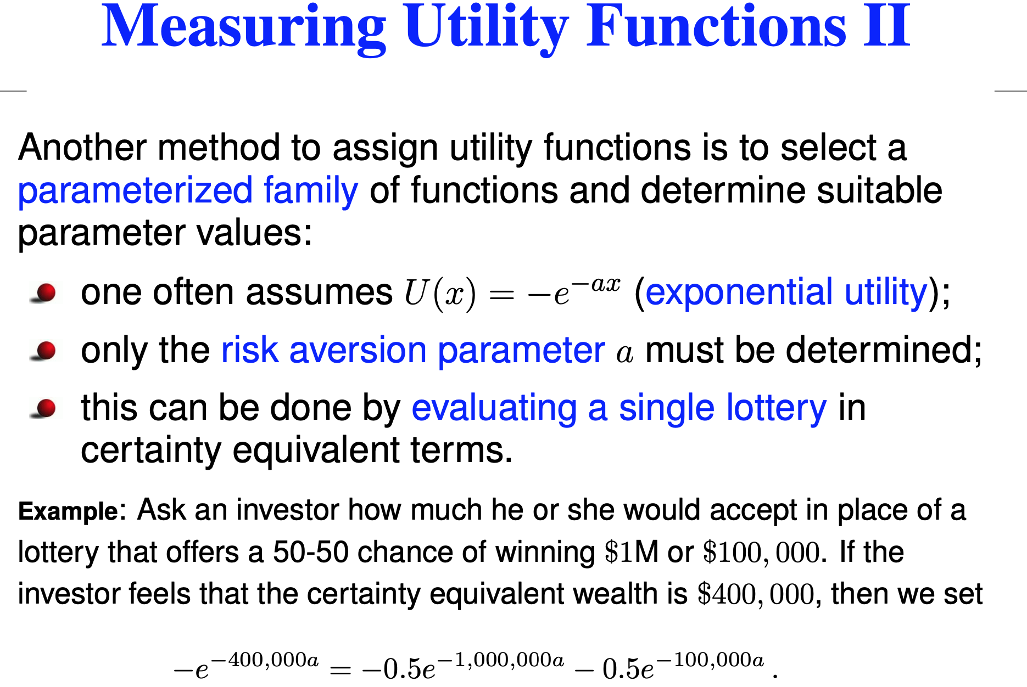

What's the third method 🙁 (Ask them!!)

B) w1 = 0.69, w2 =0.31 // (Another Answer) w1 = 0.44 w2 = 0.56 (obv wrong, market cap for asset 2 is much lower)

C) Tutorial 9 Excersise 3